**EC21101 (Basic Electronics-Class Test 1-MCQ: 20 questions; 2 marks each)**

1. Calculate time constants if R1=82 kΩ, C1=56 pF, and R2=680 kΩ, C2=33 nF.

a. 4.592 µs and 22.44 ms

b. 4.592 µs and 2. 244 µs

c. 4.592 ms and 22.44 ms

d. 45.92 ns and 224.4 ms

ANS: a

2. Cut-off frequency (fc) of a first order RC low pass filter is expressed as; Find fc if R=220 kΩ and C=92 pF

a. 1/2πRC; 7.863 kHz

b. 1/4πRC; 78.63 kHz

c. 1/6πRC; 786.3 kHz

d. 1/8πLRC; 7.863 kHz

ANS: a

3. Identify the circuit and determine the output waveform at a very low frequency:

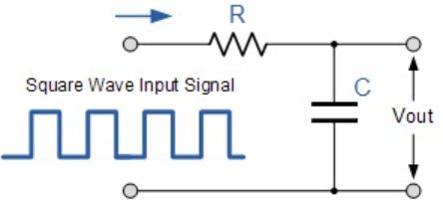:

a. Band pass filter, triangular wave

b. High pass filter, spike wave

c. Low pass filter, square wave

d. Low pass filter, sine wave

ANS: c

4. Consider the following figure. Identify the circuit that will produce such a frequency response. Calculate R, if ωB=1 MHz and C=120 nF.

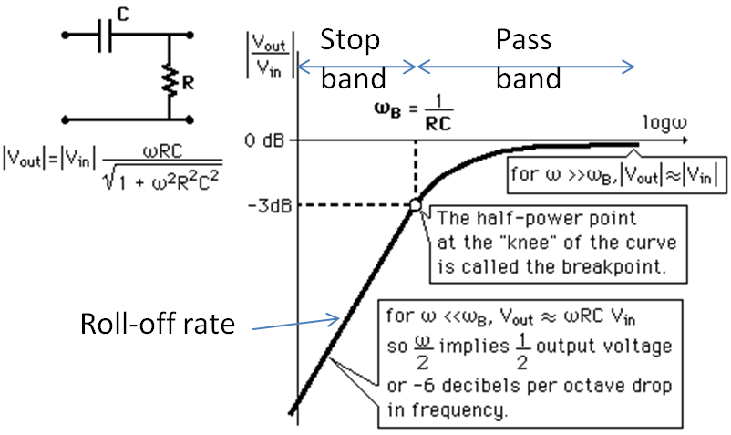

a. All pass filter, 8.333 kΩ

b. Band pass filter, 8.333 Ω

c. Low pass filter, 8.333 Ω

d. High pass filter, 8.333 Ω

ANS: d

5. Intrinsic carrier concentration of silicon (Si) slab is 1.5 x 1010 cm-3 at room temperature. If constant/ co-efficient for Si is 5.23x1015 cm-3K-3/2, Boltzmann's constant (k) is 86x10-6 eV/K, calculate the forbidden energy gap.

a. 1.4 eV

b. 1.1 eV

c. 0.66 eV

d. 1.1 nJ

ANS: b

6. Calculate junction capacitance (Cj) of a silicon based PN junction diode, if Cj0=0.8pF, Vbi=0.65V, and reverse biasing potential is 3 V.

a. 112.53 fF

b. 337.59 fF

c. 0.98 pF

d. 1.05 pF

ANS: a

7. Calculate built-in potential of a silicon based PN junction diode if Na=1016 cm-3, Nd=1015 cm-3, VT=26 mV, and ni=1.6x1011 cm-3.

a. 0.5143 V

b. 0.6803 V

c. 0.7585 V

d. 0.8015 V

ANS: a

8. Find the current through a forward biased diode if vD=1.5 V, Is=10-15 A, ideality factor n=2, and thermal voltage VT is 0.026 V

a. 1.37 mA

b. 2.37 mA

c. 3.37 mA

d. 4.37 mA

ANS: c

9. Find vD if T=300 K, n=1, VT=26 mV, Is=10-14 A and iD=10-14 A

a. +0.65 V

b. -0.65 V

c. +0.7 V

d. -0.7 V

ANS: d

10. A full wave rectifier and a capacitor filter is considered along with a center tapped power transformer. Calculate the ripple voltage magnitude if the filter component is 68 µF, maximum rectified voltage is 12 V, mains frequency is 50 Hz, and the load resistance is 15 kΩ.

a. 117.64 mV

b. 208.23 mV

c. 314.75 mV

d. 404.96 mV

ANS: a

11. Consider a voltage regulator circuit. Calculate no-load voltage if percentage load voltage regulation is 2 %, and a full load voltage is 23 V.

a. 24.12 V

b. 23.46 V

c. 22.54 V

d. 21.78 V

ANS: b

12. Calculate percentage source/ line voltage regulation if maximum change in load voltage ranges between 6.1 and 6.2 V, while input DC changes in between 11.6 to 13.2 V.

a. 4.55 %

b. 5.21 %

c. 6.25 %

d. 7.15 %

ANS: c

13. Identify the circuit and its output waveform.

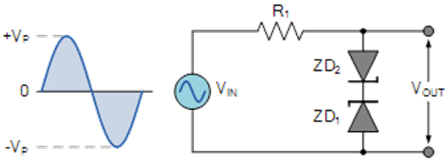

a. Clipper, 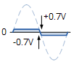

b. Rectifier, 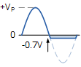

c. Clamper, 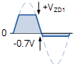

d. Clipper, 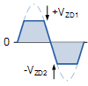

ANS: d

14. Find V1, V2, V3 and V4 for the following circuit.

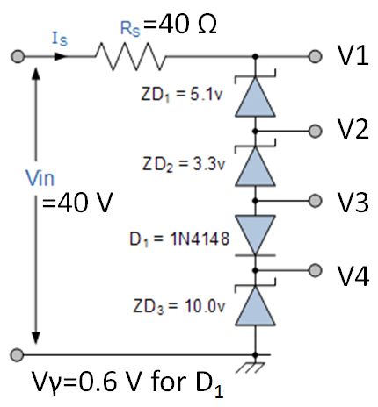

a. 18.6, 13.6, 10.9 and 10

b. 19.0, 13.9, 10.6 and 10

c. 17.6, 12.6, 11.3 and 10.6

d. 16.1, 14.5, 13.2, 11.1

ANS: b

15. Identify the circuit and its output waveform.

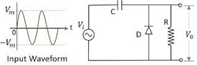

a. Clipper, 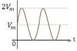

b. Clamper, 

c. Clipper, 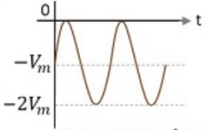

d. Clamper, 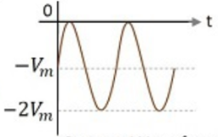

ANS: b

16. In a BJT, its emitter region has the following characteristics:

a. Smallest volume, moderate doping concentration among the three layers

b. Moderate volume, lowest doping concentration among the three layers

c. Moderate volume, highest doping concentration among the three layers

d. Largest volume, highest doping among the three layers

ANS: c

17. Calculate IB in a BJT common emitter configuration, if β=90, and IC=333 mA.

a. 0.65 mA

b. 1.8 mA

c. 2.2 mA

d. 3.7 mA

ANS: d

18. If α= 0.92, calculate β for the same BJT.

a. 11.5

b. 40.3

c. 85.6

d. 99

ANS: a

19. Base width modulation of a BJT in forward active mode for a common-emitter circuit occurs mainly due to:

a. Forward biased base-emitter junction

b. Reverse biased collector-base junction

c. Forward biased collector-base junction

d. Reverse biased base-emitter junction

ANS: b

20. A operating point (quiescent or q-point) is an intersection between:

a. Transfer characteristics of a diode or transistor and its load line

b. Transfer characteristics of a diode or transistor and its knee point

c. V-I characteristics of a diode or transistor and its load line

d. V-I characteristics of a diode or transistor and its knee point

ANS: c